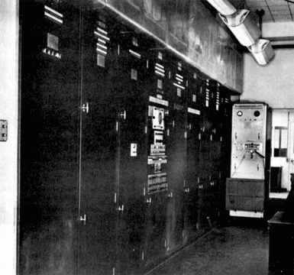
History of Computer Science

On this page, answer the following questions in point-form and then print the sheet and hand it in.

- Name two disadvantages to the Pascaline.

- What company eventually evolved from the firm Hollerith created to market his tabulator?

- Explain the Binary System that Zuse’s Z3 machine used.

- What was the primary advantage of the Von Neumann stored-program technique?

- What type of system did the EDVAC use simplifying the construction of the arithmetic units?

- What are the two devices invented in the 1950’s that enabled computers to become smaller and more economical? What was the main advantage of each?

- What was the purpose of the first microprocessor?

- Why was BASIC designed?

- By the early 1980’s what two companies were leading in developing personal computers?

- What does the word application mean?

- Why was the World Wide Web developed?

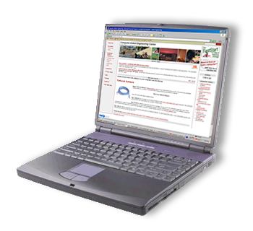
- What two fundamental things are necessary for the Web to work?

